IV. System Coding

4.1 MENU TREE/SITEMAP
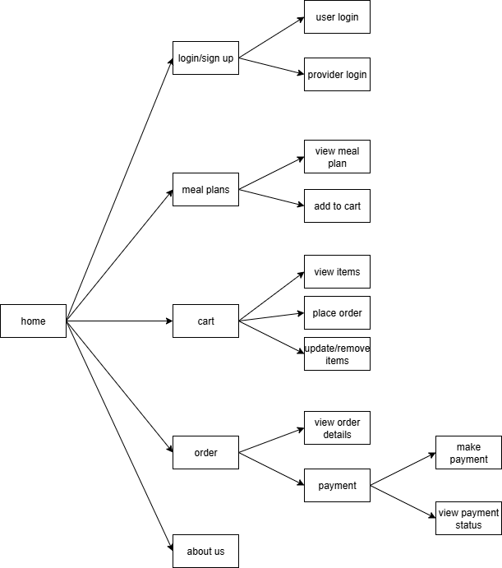
This diagram represents the navigational structure of the food ordering application, starting from the Home page. From Home, the user can access various sections of the system.
4.1.1 Home Page (Root Node)
- The central entry point of the application.
4.1.2 Login/Sign Up
- From here, the user can either:
  - User Login → for customers.
  - Provider Login → for meal providers.
4.1.3 Meal Plans
- This section allows the customer to:
  - View Meal Plan → browse available meal plans.
  - Add to Cart → add selected meals to their cart.
4.1.4 Cart
- Inside the cart, the customer has multiple options:
  - View Items → check what has been added to the cart.
  - Place Order → proceed with ordering.
  - Update/Remove Items → modify cart contents before finalizing.
4.1.5 Order
- Once an order is placed, the user can:
  - View Order Details → check summary of placed orders.
  - Payment → make payment for the order.
    - Make Payment → complete the payment transaction.
    - View Payment Status → check whether the payment succeeded or failed.
4.1.6 About Us
- Static informational section providing details about the company/service.
4.2 DATA DITCIONARY
Field | Type | Constraints
User
user id (PK) | INT | PRIMARY KEY, Auto Increment, Not Null
name | VARCHAR | Not Null
email | VARCHAR | UNIQUE, Not Null
Password | VARCHAR | Not Null
phone no | VARCHAR | Not Null
Cart
cart id (PK) | INT | PRIMARY KEY, Auto Increment, Not Null
user id (PK) | INT | FOREIGN KEY REFERENCES User(user id)
address | VARCHAR | Not Null
Order
order id (PK) | INT | PRIMARY KEY, Auto Increment, Not Null
cart id (PK) | INT | FOREIGN KEY REFERENCES User(user id)
total amount | DECIMAL | Check(total_amount>=0), Not Null
order date | DATE | Not Null
Payment
payment_id (PK) | INT | PRIMARY KEY, Auto  Increment, Not Null
order_id (FK) | INT | FOREIGN KEY REFERENCES  Order(order_id)
amount | DECIMAL | Check(amount>=0), Not Null
status | ENUM | Values(Pending, Completed, Failed), Not Null
method | VARCHAR | Not Null
transaction_id | VARCHAR | Unique, Not Null
Meal Plan
meal_id (PK) | INT | PRIMARY KEY, Auto  Increment, Not Null
provider_id (FK) | INT | FOREIGN KEY REFERENCES  Provider(provider_id)
title | VARCHAR | Not Null
price | DECIMAL | Check(price>=0), Not Null
Provider
provider_id (PK) | INT | PRIMARY KEY, Auto  Increment, Not Null
name | VARCHAR | Not Null
email | VARCHAR | UNIQUE, Not Null
password | VARCHAR | Not Null
phone_no | VARCHAR | Not Null
address | VARCHAR | Not Null
menu | TEXT | Nullable
Data Dictionary specifies how data is stored, organized, and constrained within the system’s database. It defines each entity in detail, including primary keys, foreign keys, data types, and integrity constraints.
4.2.1. User Table
- Fields: user_id (PK), name, email, password, phone_no
- Constraints:
  - user_id is auto-increment and primary key.
  - email must be unique and not null.
  - All fields are mandatory (Not Null).
4.2.2. Cart Table
- Fields: cart_id (PK), user_id (FK), address
- Constraints:
  - cart_id is primary key, auto-increment.
  - user_id references User(user_id).
  - address is required.
4.2.3. Order Table
- Fields: order_id (PK), cart_id (FK), total_amount, order_date
- Constraints:
  - order_id is primary key, auto-increment.
  - cart_id references Cart(cart_id).
  - total_amount must be ≥ 0.
  - order_date cannot be null.
4.2.4. Payment Table
- Fields: payment_id (PK), order_id (FK), amount, status, method, transaction_id
- Constraints:
  - payment_id is primary key, auto-increment.
  - order_id references Order(order_id).
  - amount must be ≥ 0.
  - status can only be Pending, Completed, or Failed.
  - transaction_id must be unique and not null.
4.2.5. Meal Plan Table
- Fields: meal_id (PK), provider_id (FK), title, price
- Constraints:
  - meal_id is primary key, auto-increment.
  - provider_id references Provider(provider_id).
  - price must be ≥ 0.
  - title is required.
4.2.6. Provider Table
- Fields: provider_id (PK), name, email, password, phone_no, address, menu
- Constraints:
  - provider_id is primary key, auto-increment.
  - email must be unique and not null.
  - menu can be nullable, other fields are required.

4.3 Design Patterns Used
4.3.1 Backend (Node.js/Express)
- Model-View-Controller (MVC) The backend structure is a classic example of the MVC pattern, adapted for a REST API.
  - Model: The models/ directory contains Mongoose schemas. These define the structure of the data (like User, Provider, Order) and handle all interactions with the MongoDB database. They represent the data and business logic layer.
  - Controller: The controllers/ directory handles the application logic. It receives incoming requests forwarded from the routes, processes them by interacting with the Models, and sends a response back to the client.
  - View (as API Routes): In a traditional web application, the View is the UI (e.g., HTML templates). For this REST API, the routes/ directory defines the API endpoints. The "view" is the JSON data that is rendered and sent back to the client.
- Middleware Pattern (Chain of Responsibility) Express.js is built heavily on the concept of middleware. The project explicitly has a middleware/ directory for authentication.
  - How it's used: Middleware functions are pieces of code that have access to the request (req), response (res), and the next middleware function in the application’s request-response cycle. They can execute code, make changes to the request and response objects, and end the cycle or pass control to the next middleware.
  - Example: The JWT authentication middleware checks for a valid token on protected routes. If the token is valid, it passes the request to the controller; if not, it sends an error response, effectively acting as a gatekeeper. This is a form of the Chain of Responsibility pattern.
4.3.2 Frontend (JavaScript)
- Module Pattern The project structure separates JavaScript logic into different files like main.js and provider-auth.js. Modern JavaScript (ES6+) encourages this through its native module system (import/export). This pattern is used to:
  - Encapsulate code into logical, private scopes.
  - Organize the codebase into smaller, maintainable files.
  - Avoid polluting the global namespace, which prevents naming conflicts.
- Observer Pattern (Implied) The README.md mentions a feature for "Real-time updates." While the exact implementation isn't detailed, this functionality typically relies on the Observer pattern.
  - How it works: A "subject" (like an order status manager) maintains a list of its dependents, called "observers" (like UI components). When the subject's state changes, it automatically notifies all its observers, which then update themselves. This is essential for features like live order tracking or dashboard updates without needing to refresh the page.

4.4 Source Code
index.html
login.html
register.html
style.css
\js\main.js
dabbewala-backend\server.js
const express = require("express");
const cors = require("cors");
const dotenv = require("dotenv");
const connectDB = require("./config/db");
dotenv.config();
const app = express();
// Middleware
app.use(express.json());
// Flexible CORS configuration for local development and production
const allowedOrigins = [
"https://dabbewale.netlify.app", // Production frontend
"http://localhost:8000", // Common local server port
"http://127.0.0.1:5500" // For Live Server extension
];
app.use(cors({ origin: (origin, callback) => {
// Allow requests with no origin (like mobile apps or curl requests) or from whitelisted domains
if (!origin || allowedOrigins.includes(origin)) { callback(null, true); }
else { callback(new Error(`Origin '${origin}' not allowed by CORS`)); }
}}));
// Connect DB (this already prints your custom logs!)
connectDB();
// Routes
app.use("/api/auth", require("./routes/authRoutes"));
app.use("/api/providers", require("./routes/providerRoutes"));
app.use("/api/orders", require("./routes/orderRoutes"));
// Test route for admin panel API check
app.get("/api/test", (req, res) => {
res.json({ message: "✅ API is reachable" });
});
// Health check route
app.get("/", (req, res) => {
res.json({ message: "✅ Server is running", timestamp: new Date().toISOString() });
});
// Start server
const PORT = process.env.PORT || 5000;
app.listen(PORT, () => {
console.log(`🚀 Server running on port ${PORT}`);
});
dabbewala-backend\config\db.js
const mongoose = require("mongoose");
// Fail fast rather than buffering model operations when disconnected
mongoose.set('bufferCommands', false);
const connectDB = async () => {
try {
console.log("🔌 Attempting to connect to MongoDB...");
console.log("📡 MongoDB URI:", process.env.MONGO_URI || "Not set - using default");
const mongoURI = process.env.MONGO_URI || "mongodb://localhost:27017/dabbewala";
await mongoose.connect(mongoURI, {
serverSelectionTimeoutMS: 20000, // wait up to 20s to find a server
socketTimeoutMS: 45000,
});
console.log("✅ MongoDB Connected Successfully!");
console.log("📦 Connected to database:", mongoose.connection.name);
console.log("🌐 MongoDB URL:", mongoose.connection.host + ":" + mongoose.connection.port);
} catch (err) {
console.error("❌ MongoDB Connection Error:", err.message);
console.error("💡 Make sure MongoDB is running and MONGO_URI is set correctly");
console.error("🔧 For local development, install MongoDB or use MongoDB Atlas");
process.exit(1);
}
};
module.exports = connectDB;

V. System Implementation

5.1 H/W and S/W Requirements
5.1.1. Software Requirements
The software requirements are categorized based on the environment: End-User (Client), Developer (Local), and Production (Hosting).
1. End-User Requirements (Client-Side)
These are the requirements for customers and providers to use the live application.
- Operating System: Any modern OS is supported.
  - Windows 10 or newer
  - macOS
  - Linux Distributions
  - Android
  - iOS
- Web Browser: An up-to-date web browser with support for HTML5, CSS3, and modern JavaScript (ES6+).
  - Google Chrome (recommended)
  - Mozilla Firefox
  - Microsoft Edge
  - Safari
- Internet Connection: A stable internet connection is required to access the live website and interact with the backend services.
2. Developer Requirements (Local Environment)
These are the tools and software needed for a developer to set up, run, and contribute to the project locally.
- Operating System: A developer-friendly OS.
  - Windows, macOS, or a Linux distribution.
- Version Control:
  - Git: For cloning the repository and managing code versions.
- Backend Stack:
  - Node.js: Runtime environment (includes npm for package management).
  - MongoDB: Database for storing application data. This can be set up in two ways:
    - MongoDB Community Server: For running a local database instance.
    - MongoDB Atlas: A cloud-hosted database service (recommended for ease of setup).
- Code Editor/IDE: Any modern text editor or Integrated Development Environment.
  - Visual Studio Code (recommended)
  - WebStorm
  - Sublime Text
- Local Web Server (for Frontend): An optional but recommended tool for serving the frontend files.
  - Python's built-in http.server
  - Node.js http-server package
3. Production Requirements (Deployment & Hosting)
These are the services used to host the live application.
- Frontend Hosting: A service for deploying static web content.
  - Netlify (as specified in README.md)
- Backend Hosting: A Platform-as-a-Service (PaaS) that can run a Node.js application.
  - Render (as specified in README.md)
  - Alternatives include Heroku, AWS, or a traditional VPS.
- Database Hosting: A production-grade, managed database service.
  - MongoDB Atlas (as specified in README.md)

5.1.2. Hardware Requirements
1. End-User Hardware
- Any device capable of running a modern web browser.
  - Desktop Computer
  - Laptop
  - Tablet
  - Smartphone
2. Developer Hardware
- A standard development machine (laptop or desktop) with sufficient resources.
  - Processor: A modern multi-core CPU.
  - Memory (RAM): 8 GB is recommended for a smooth development experience (running the database, server, and code editor simultaneously).
  - Storage: At least 10-20 GB of free disk space for project files, dependencies, and database storage.
3. Production Hardware
- This is fully managed by the cloud service providers (Netlify and Render). The hardware resources are allocated and scaled by the provider based on the chosen service plan and application traffic. The developer does not need to manage any physical hardware.

5.2 Screen / Report Layouts
Home Page
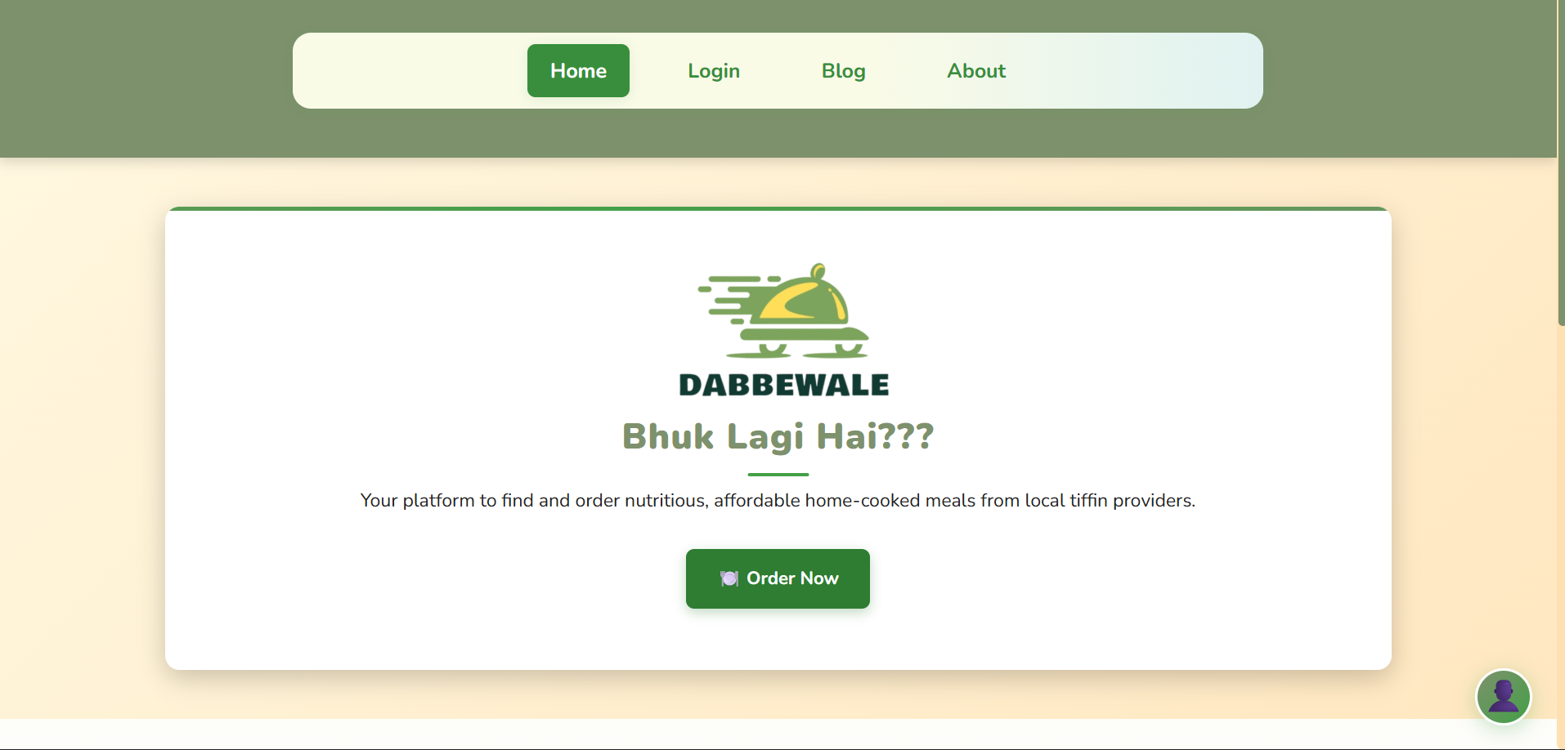
Footer & Testimonials
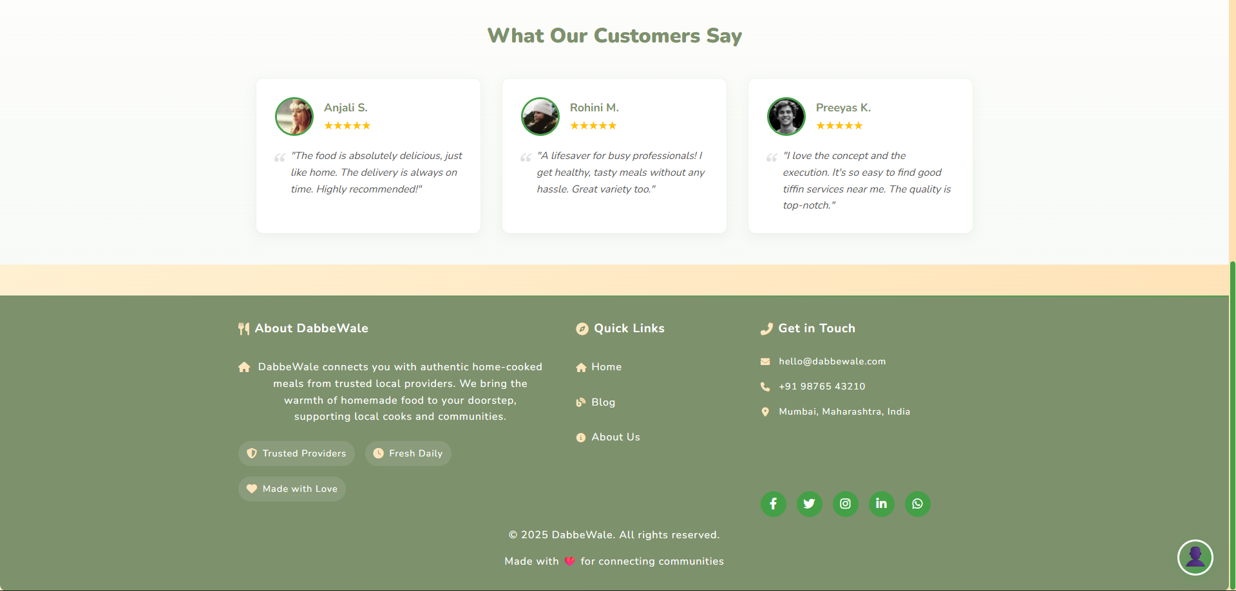
Login
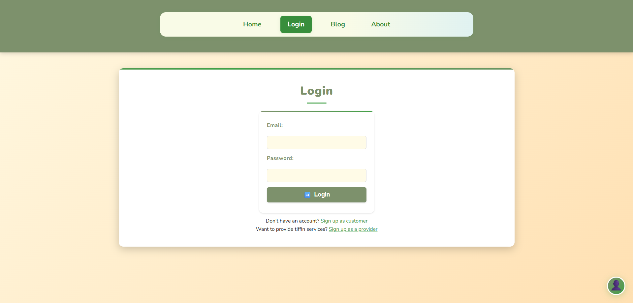
Customer Registration
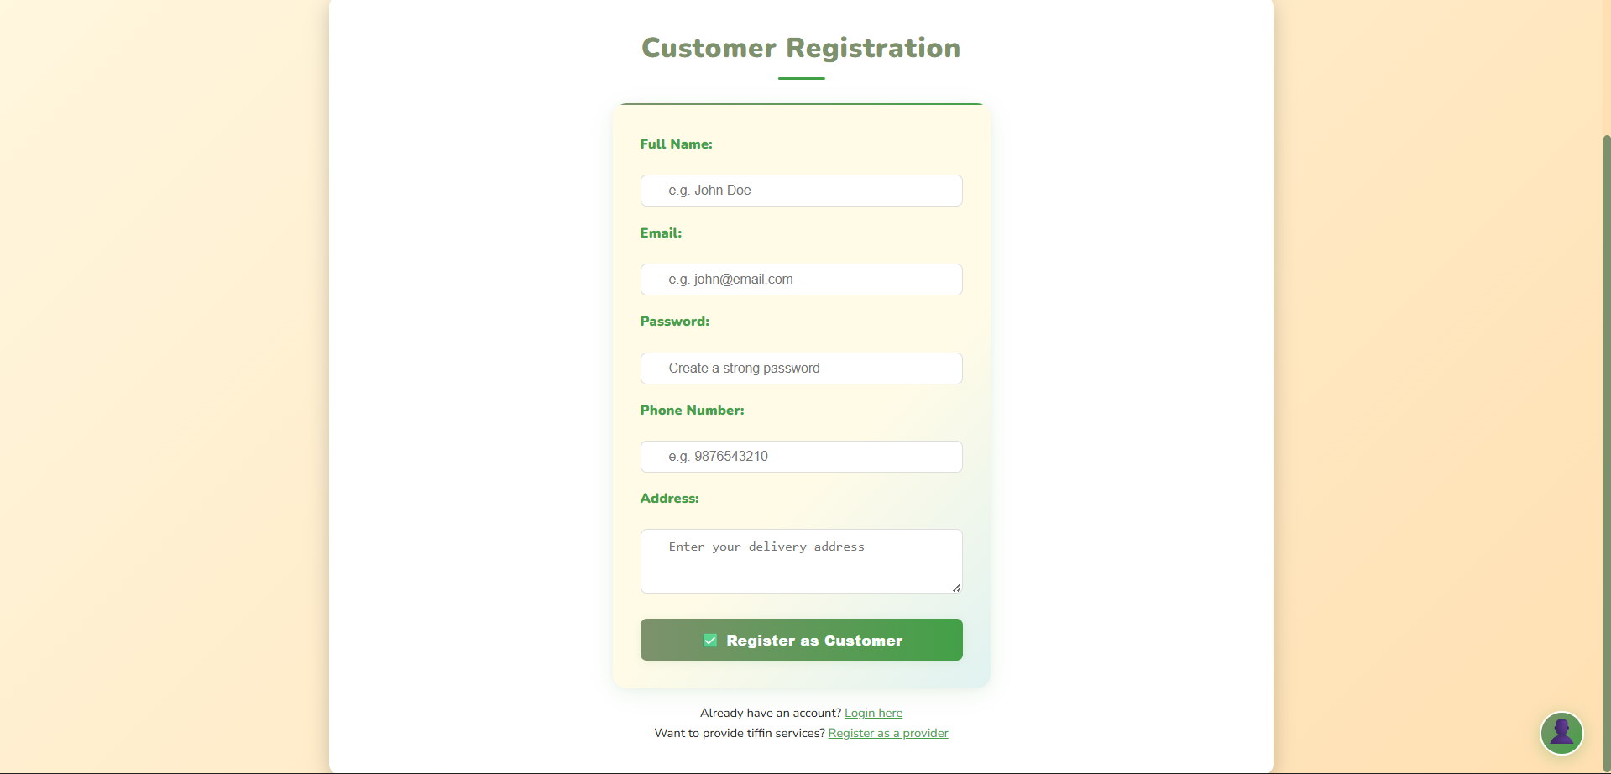
Provider Registration
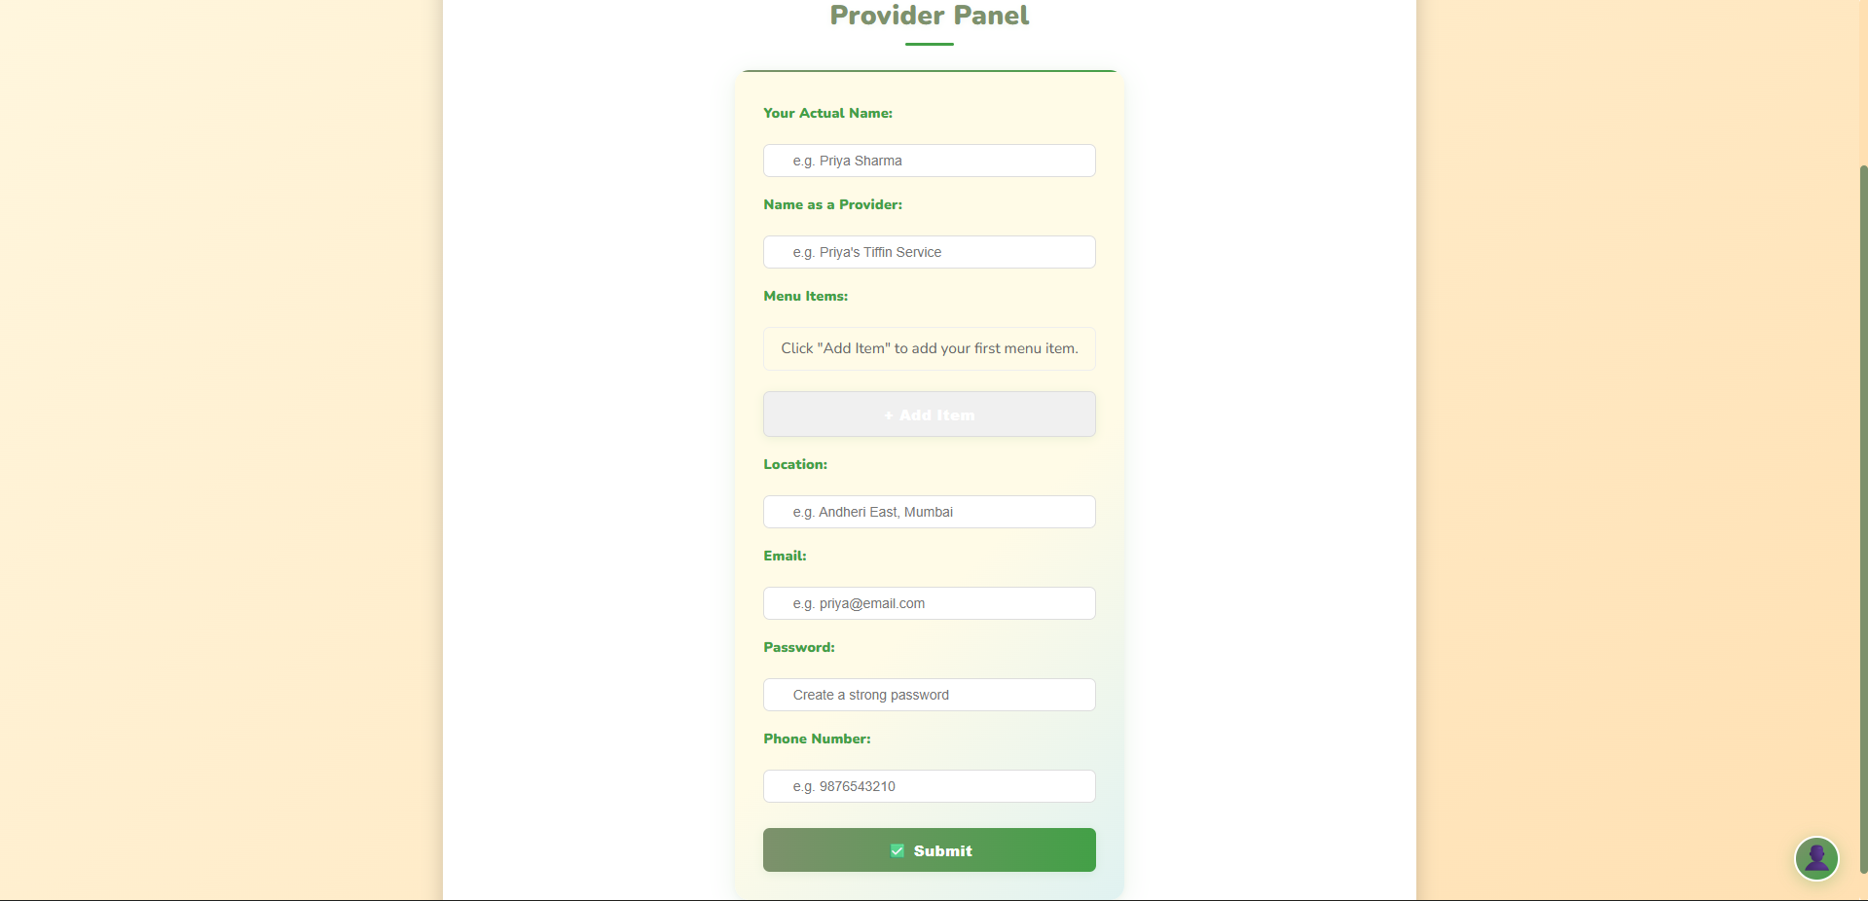
Order
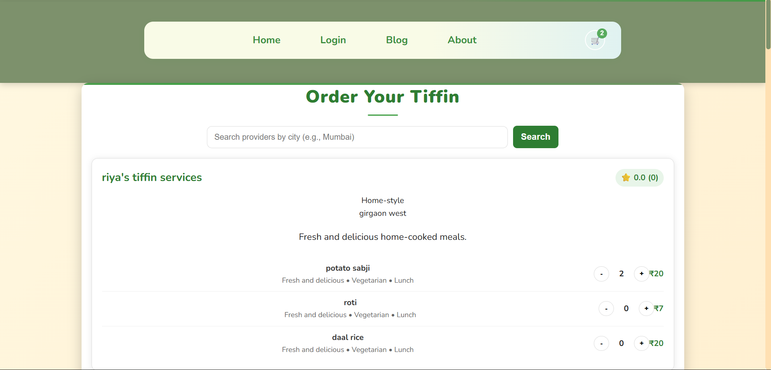
Cart
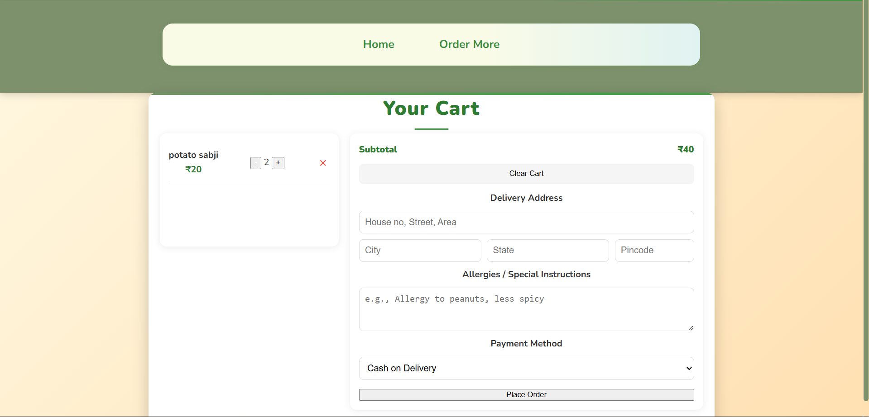

VI. Future Enhancements

6.1 Payment Gateway Integration
- Why: Automates payments, reduces manual work, builds trust.
- How: Use Razorpay/PayU with Node.js SDKs. Add initiate payment endpoint, handle webhooks for success/failure, and securely store transactions.
6.2 Rating & Review System
- Why: Builds trust and feedback loop for providers.
- How: Add rating and review fields to orders, create review API endpoint, show average rating on provider profile.
6.3 Order Tracking Enhancements
- Why: Makes updates more visual and engaging.
- How: Add live map (future mobile app) and granular statuses (Pending, Accepted, Preparing, Out for Delivery, Delivered, Cancelled).
6.4 Advanced Search & Filtering
- Why: Helps users find the right meals as providers grow.
- How: Extend /api/providers with filters for cuisine, diet, price range, and minimum rating.
6.5 Subscription Management
- Why: Supports weekly/monthly tiffin subscriptions, a key business model.
- How: Add subscription models linking users, providers, and plans. Build UI for subscribe/pause/resume/cancel. Automate order creation based on active subscriptions.
6.6 Comprehensive Admin Dashboard
- Why: Centralized control for managing the platform.
- How: Add protected admin section to view/manage users, providers, and orders. Handle disputes/refunds, onboard providers, and show analytics (revenue, sign-ups, etc.).
6.7 Promotions & Coupon System
- Why: Marketing tool to attract and retain customers.
- How: Create coupon model (code, discount type/value, expiry). Add validation logic in order process to apply discounts.

VII. References and Bibliography

- ReactJS – Frontend framework. https://reactjs.org
- Node.js – Backend runtime. https://nodejs.org
- Express – Server routing and APIs. https://expressjs.com
- MongoDB – Database management. https://www.mongodb.com
- GeeksforGeeks – Tutorials and guidance. https://www.geeksforgeeks.org

VIII. Annexures

8.1 Proposal
DabbeWale is a full-stack web app connecting home-based tiffin providers with customers seeking healthy, affordable meals. Inspired by Mumbai’s Dabbawalas, it offers a centralized marketplace with provider visibility, customer trust, and a reliable food solution. The live platform features a responsive UI, secure authentication, provider discovery, and order management.
8.1.1 Problem Statement
- Consumers: Struggle to access daily, healthy, and affordable meals; alternatives are costly or unhealthy.
- Providers: Talented home cooks lack visibility, marketing tools, and digital infrastructure to scale.
8.1.2 Proposed Solution
- Marketplace: Centralized platform for discovering verified tiffin providers, with location-based search.
- Provider Empowerment: Easy provider dashboard to manage menus, orders, and customers.
- Community Trust: Planned rating/review system for transparent, quality-driven growth.
8.1.3 Key Features
- Dual role system (Consumers/Providers).
- Secure JWT authentication with bcrypt password hashing.
- Location-based provider discovery.
- Provider panel for menu and service management.
- Responsive, mobile-first UI with light/dark mode.
- Basic order management system.
- Live deployment (Frontend: Netlify, Backend: Render).
8.1.4 Technical Architecture
- Frontend: HTML5, CSS3, JavaScript (ES6+); responsive UI; hosted on Netlify.
- Backend: Node.js + Express.js, MongoDB + Mongoose, REST API with MVC structure.
- Security: JWT authentication, bcrypt, CORS policy.
- Deployment: Hosted on Render.
8.1.5 Future Roadmap
- Payment Gateway Integration: Razorpay/PayU for automated payments.
- Rating & Review System: Customer feedback and provider insights.
- Advanced Search & Filtering: By cuisine, diet, price, rating.
- Subscription Management: Weekly/monthly plans.
- Admin Dashboard: Platform-wide control and analytics.
- Mobile App: Native/cross-platform apps with push notifications.

8.2 Phase Completion Table

8.3 Gantt Chart

